

TWO BUS TRANSMISSION LINE

STUDENT NAME : DISHA HARWALKAR
STUDENT ID : 001158836
MODULE TITLE : POWER SYSTEM ANALYSIS
(ELEC 1041)
PROGRAMME : MSc IN ELECTRICAL AND
OF STUDY ELECTRONICS ENGINEERING

DATE : 22/11/2021

Submitted to : Yehdego Habtay
AIM:
To analyze and study the real power and reactive power flow in a one-line diagram of a two-bus system on power world simulator application. To also study the effect of change in the magnitudes of voltages at bus ONE and bus TWO and their bus angles and how the flow of reactive power and real power flow takes place as we change the loads in MW and MVAR values.
INTRODUCTION:
Real power is the apparent or the imaginary power caused by inductive or capacitive nature of the load when there is a phase shift between the loads. Real power on the other hand is the actual power consumed by the load due to the resistive nature of the load. Real and reactive power flows between bus systems in real life so in order to understand and study the actual power flow we use an example of a two- bus system we analyze the real and reactive power flow in a two- bus system by simulating on power simulator application. Power simulator gives an idea as to how the flow of powers between bus systems take place in real life. Power simulator is chosen over MATLAB and Lab view as it is far more appropriate to analyze power networks since MATLAB and Lab view are difficult to modify different networks.

PROCEDURE:
- Open the power world simulator application and click on new case under the file icon.
- We then draw a one-line diagram for a two-bus system with the following parameters:
- Nominal voltage at bus ONE and TWO = 138KV
- MW rating of generator = 1000MW
- Load rating = 500MW
- Transmission line has: R(RESISTANCE)= 0.02, X(REACTANCE)= 0.08 AND B(SHUNT CHARGING CAPACITANCE) = 0.8
- With base value 500MVA

- We then changed the base MVA value from 100MVA to 500MVA of the transmission line by clicking on the simulator options, click on the general option to change the base values, and then change the transmission line parameters from the preset values to the values given (when we change the values from 100MVA to 500MVA, the values of the transmission line parameters change.
- Click on the animation sub icon under the options icon, and change the flow viz type from actual MW to Actual MW and actual MVAR to see the flow of real and reactive power as well.
- Click on run mode and click on play option to see the flow of real and reactive power.
- While on run mode double click on load fields in MW, BY CLICKING ON DELTA PER MOUSE CLICK from 0 to 50MW, to change the load values in MW, and from 0to 25MVAR to change the loads in steps of 50MW and 25 MVAR values respectively.
- Now vary the load in MW in steps of 50MW from 0-1000MW, keeping MVAR value as 0, to observe the changes of real and reactive power flow in the line.
- Now plot the graph for change in bus angle (in degrees) and voltage magnitude (in KV) at load as a functions real power in steps of 50MW.
- Repeat step 7 but instead keep the constant MW value of 500 and vary the MVAR value in steps of 25MVAR from 0-500MVAR, to notice the change in real power flow and reactive power flow in the transmission line towards the load.
- Now plot the graph for change in bus angle (in degrees) and voltage magnitude (in KV) at load as a functions reactive power in steps of 25mvar.
TASKS:

TASK 1
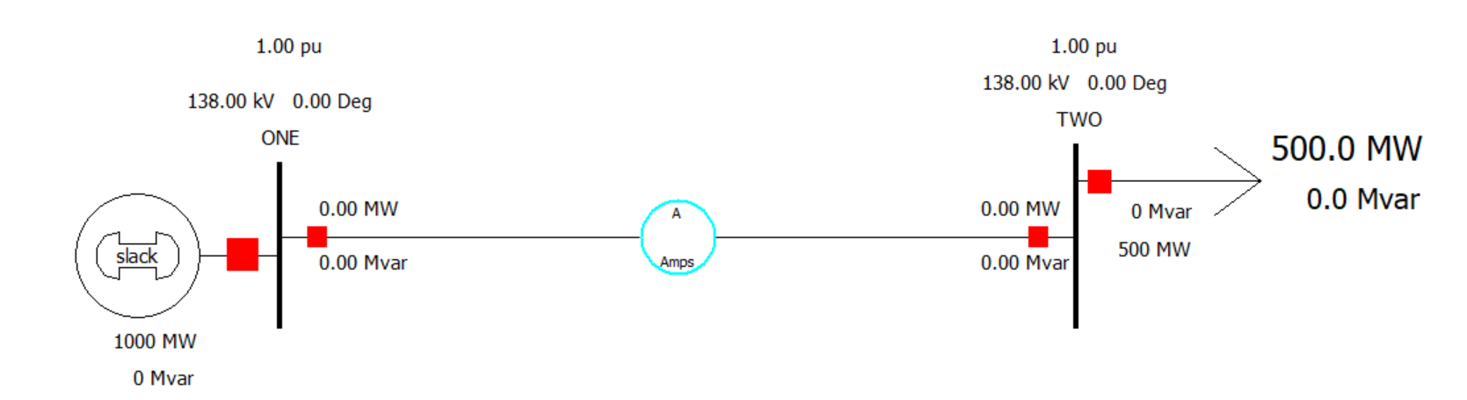
Fig 1

Fig 1 depicts a one-line diagram of a two-bus system with bus ONE and bus TWO, the generator is a slack bus which means that it is a reserve of difference in voltages present between or at the bus voltages. The circle in the middle signifies the percentage loading the of line which means percentage of maximum amount of power that can flow in a line without exceeding the limits or the percentage of the line impedance being used. At present it is 0 % which means that there is no power flow in the transmission line at the moment or 0% of the overall line impedance capacity is being used. The p.u values indicates proportion of nominal voltage present at that particular bus. it is given by the division between the nominal voltage and the actual voltage flowing in the line. Since we have impedance which has some inductance, capacitance and resistance so the voltage drop will be current multiplied with the impedance of the line. this difference in voltage will give the voltage regulation. By looking at the p.u values it can be indicated if the system is complying within the p.u values. And if the voltage regulation of the system is efficient or not. At present without simulation, it is 1 p.u which means that the total nominal voltage of 138KV is present at buses 1 and 2. We can check the percentage of line loading, or the amount of current transferred by simply double clicking on the circle to see how much of the line loading has been used. the transmission line is a line suspended above the ground and since it is insulated from the ground, it has a different voltage from that of ground. The transmission line forms a capacitor between the wire and the ground, and this is called a shunt charging capacitance, this injects current into the transmission line causing reactive power to flow just like a capacitor bank, but much weaker.
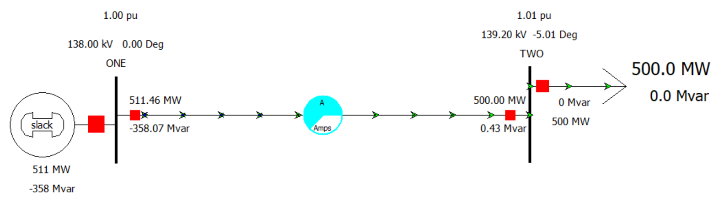
TASK 2
Fig 2

Fig 2 shows the simulation process of a two-bus system, the green arrows depict the flow of real power whereas the blue arrows show the flow of reactive power. The size of the arrows indicate the proportionality of the power flow. Since the arrows are small which means that a small percentage of line loading is being used or a small percentage of line impedance is being used. There is a mismatch in the voltages due to the line resistance there will be $I^{2}R$ losses so the MW and MVAR values are not the same and since we have both inductance and capacitance in the line there will be reactive power loss hence there is a mismatch of voltages.

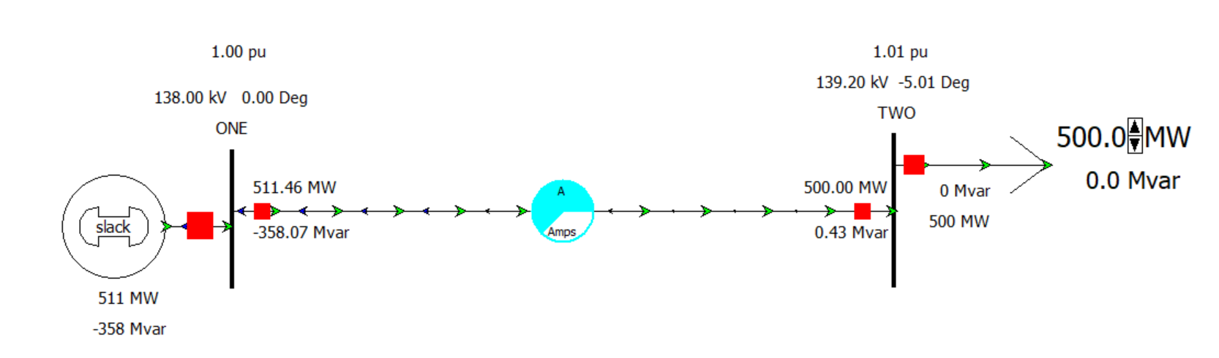
TASK 3
Fig 3
Fig 3 shows the simulation process at a load of 500MW, as it appears, the voltage in p.u is 1.01, which means that the voltage at bus TWO is higher than the bus ONE. The real power flows from a higher angle to a lower angle whereas the reactive power flows from a higher voltage magnitude to a lower voltage magnitude. Hence the real power flows from bus ONE to bus TWO and reactive power flows from bus TWO to bus ONE. At 500MW the percentage of line loading was found to be 62.43% which means that 62.43% of the overall capacity of the line impedance was used up, the line losses were found to be 11.463 MW and -357.639 MVAR. The slack bus generator’s MW and MVAR values decreased from 1000MW and 0MVAR to 511MW and -358MVAR since the power is flowing from the generator to the load so it’s power capacity decreases.

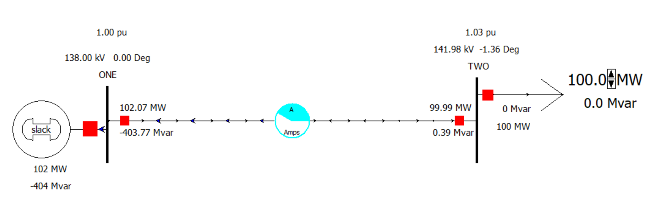
TASK 4
Fig 4
In fig 4, we change the load in MW (real power) in steps of 50MW from 0 MW to 1000MW keeping the reactive power of the load at 0MVAR constant, to observe the changes in the flow of real and reactive power across the transmission line and how it affects the voltages at bus ONE and bus TWO. A graph was plotted with voltage magnitudes and bus angles as a function of real power. Observations were made.
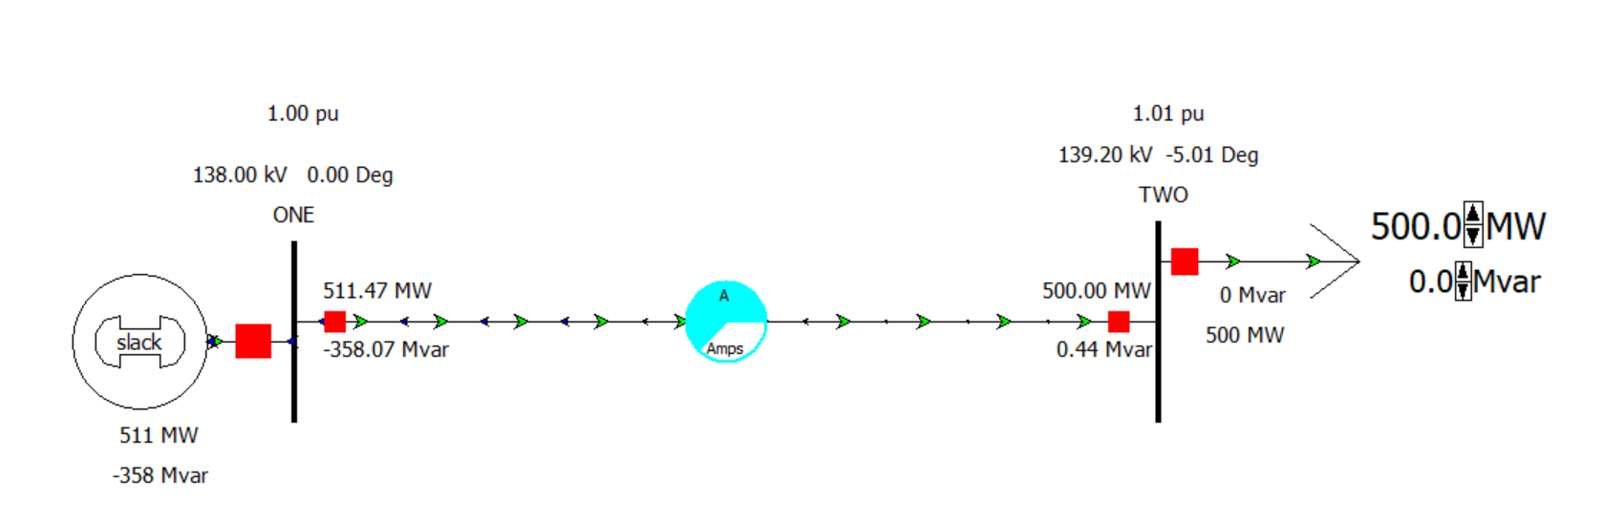
TASK 5
Fig 5

In fig 5, we change the load in MVAR (reactive power) in steps of 25MVAR from 0 MVAR to 500MVAR keeping the real power of the load at 500MW constant, to observe the changes in the flow of real and reactive power across the transmission line and how it affects the voltages at bus ONE and bus TWO. A graph was plotted with voltage magnitudes and bus angles as a function of reactive power. Observations were made.

GRAPH AND OBSERVATIONS:
- CHANGE IN LOAD IN STEPS OF 50MW VS VOLTAGE MAGNITUDES AND BUS ANGLES AS A FUNCTION OF REAL POWER:

Change in load in MW(REAL POWER) | BUS VOLTAGE AT BUS TWO IN KV | BUS VOLTAGE ANGLE AT BUS TWO IN DEGREE
0 | 142.57 | -0.46
50 | 142.28 | -0.92
100 | 141.98 | -1.36
150 | 141.67 | -1.81
200 | 141.35 | -2.26
250 | 141.02 | -2.71
300 | 140.68 | -3.17
350 | 140.32 | -3.62
400 | 139.96 | -4.08
450 | 139.59 | -4.55
500 | 139.2 | -5.01
550 | 138.8 | -5.48
600 | 138.39 | -5.96
650 | 137.97 | -6.43
700 | 137.53 | -6.91
750 | 137.08 | -7.4
800 | 136.62 | -7.89
850 | 136.14 | -8.38
900 | 135.64 | -8.88
950 | 135.13 | -9.39
1000 | 134.61 | -9.9
Table 1

Fig 6

Fig 7

We observe that the real power flows from the sending end to the receiving end whereas the reactive power flows from the receiving end to the sending end. This relation can be seen from the equations below:
$P=\frac{VsVr sinδ}{X}→$Eq 1
$Q=\frac{Vr(Vscosδ-Vr)}{X}→$ Eq 2
So from equation 1 and equation 2 we get :
$P ∝δ→$ Eq 3
where $δ=δ_{s}-δ_{r}→$Eq 4
And $Q ∝\left|Vs\right|\left|Vr\right|→$Eq 5
Where P = REAL POWER
Q = REACTIVE POWER
Vr = RECIEVING END VOLTAGE AT BUS TWO
Vs = SENDING END VOLTAGE AT BUS ONE
$δ$ = BUS VOLTAGE ANGLE IN DEGREES
$δ_{s}$ = BUS VOLTAGE ANGLE AT BUS ONE IN DEGREES
$δ_{r}$ = BUS VOLTAGE ANGLE AT BUS TWO IN DEGREES
From equations above it is inferred that the flow of real power depends on the voltage angle difference between the receiving end and the sending end, and the flow of reactive power depends on the difference in the voltage magnitudes of the sending end and receiving end buses.
It appears that at the no load condition or at 0MW and 0 MVAR from table 1 and from the figures above, the voltage at bus TWO is more than that of the voltage at bus ONE. This phenomenon is referred to as the Ferranti effect. This effect is defined as: at light loads or at no load condition the receiving end voltage termed Vr is more than the sending end voltage termed Vs. Here in the figures above in the task, Vr is the voltage at bus TWO and Vs is voltage at bus ONE. This phenomenon occurs due to the inductance and capacitance present in the transmission line. At first when voltage is applied, Vs= Vr +LOSSES, but the capacitor at the transmission line starts to generate current and that current flows towards the generator so now the voltage drop will take place in the opposite direction. Hence now we sat that Vr = Vs + LOSSES.
At no load condition , phase difference between the voltages is zero so cosine of the phase difference will be maximum so at minimum loads the phase angle is small and cosine of that becomes bigger as reactance increases towards the receiving end the phase difference between the voltages keeps increasing thereby decreasing the cosine of phase difference to smaller and smaller so the magnitude of sending end voltage decreases (that is voltage at bus ONE is lower than voltage at bus2) , therefore at the beginning the voltage at bus TWO is higher than that of bus ONE.
As we increase the load from 0MW to 1000MW, it is observed that the speed of the real power increases, which indicates that more real power flows towards the load. It can be observed that as we increase the load, the voltage magnitude at bus TWO keeps decreasing thereby decreasing the voltage magnitude difference between the buses, hence the reactive power flow decreases. The bus voltage decreases too but in this case the difference in the bus angles between the buses ONE and bus TWO increases, and from equation 1 it is seen that real power depends on bus voltages so the flow of real power increases. As we increase the load, the arrows of the real power becomes bigger and bigger and the arrows of the reactive power becomes smaller and smaller. Hence in the graphs it is a downward graph of both the voltage magnitudes as a function of load in MW in figure 6.
For the bus angles vs the change in load graph from figure 7, the graph is a sharp downward graph due to the effect of $\sin{δ}$ as we increase the load the bus angles keep decreasing so the sine of the bus angles keep decreasing further so we get a steep downward graph. So more real power flows from the sending end to the receiving end.
The p.u values changed from 1.03p.u to 0.98p.u from 0 MW to 1000MW , which meant a large proportion of the nominal voltage was present at bus TWO ,hence there was no change in direction of the arrows of the reactive power as there is not much voltage drop at the bus TWO .But the arrows of the reactive power almost diminishes as it flows from the receiving end to the sending end .
There is no reactive power flow at the load side at 0 MVAR since the load is resistive in nature which means the phase of voltage and current are in phase. Only real power flows across the load. The transmission line on the other hand is capacitive in nature, this can be known by the flow of reactive power and the leading nature of the bus angle of bus TWO.
At 750MW, it was observed that 83% of line’s loading overall capacity was used. At 800MW it was 88%, at 850MW it was 92%, at 900MW it was 97%, the circle turned yellow from 750MW to 900MW indicating it as a warning sign that the line’s loading overall capacity is nearing to it’s full potential. At 950MW it was 102%, at 1000MW it was 107% the circle turned red indicating that the overall line loading capacity has reached it’s maximum point. The real power flow across the transmission line turns red.

- CHANGE IN LOAD IN STEPS OF 25MVAR VS VOLTAGE MAGNITUDES AND BUS ANGLES AS A FUNCTION OF REACTIVE POWER:
CHANGE IN LOAD IN STEPS OF 25 MVAR(REACTIVE POWER) | VOLTAGE AT BUS TWO IN KV | VOLTAGE DEGREES AT BUS2 IN DEGREES
0 | 139.2 | -5.01
25 | 138.62 | -4.97
50 | 138.04 | -4.93
75 | 137.46 | -4.89
100 | 136.88 | -4.85
125 | 136.29 | -4.81
150 | 135.69 | -4.77
175 | 135.09 | -4.73
200 | 134.48 | -4.68
225 | 133.86 | -4.64
250 | 133.24 | -4.6
275 | 132.62 | -4.56
300 | 131.98 | -4.52
325 | 131.34 | -4.47
350 | 130.7 | -4.43
375 | 130.04 | -4.39
400 | 129.38 | -4.34
425 | 128.71 | -4.3
450 | 128.03 | -4.26
475 | 127.35 | -4.21
500 | 126.65 | -4.17

Table 2

Fig 8

Fig 9

As we increase the load from 0 to 500MVAR keeping the MW load constant at 500MW, the bus voltage at bus TWO decreases further and further, so the speed of the reactive power increases therefore the size of the arrows became bigger and bigger, and more number of blue arrows started to flow this can be observed in the table 2. The p.u values changed from 1.01 p.u to 0.92p.u as we changed the loads from 0 MVAR to 500MVAR .0.92 p.u indicates that a small percentage of nominal voltage is present which is lower than the p.u value should be . this indicates that there is a large voltage drop at bus TWO, so more and more reactive power flows in order to balance out the voltage magnitude difference.
At 0.95 p.u , 300 MVAR that is 131.98 KV and -4.52 degrees , the blue arrows (reactive power flow) changed it’s direction instead of flowing from the receiving end to the load side , it started to flow from the sending end to the receiving end since the voltage at bus TWO became lower than the voltage at bus ONE . the direction of the arrows changed this time since the p.u values decreased from 1.01p.u to 0.95 p.u which is lesser than the permissible p.u value of the system. Hence, we see a steep decrease in the voltage magnitude at bus 2 as a function of reactive power, when the load was changed in steps of 25MVAR. But this is not the case when the graph was plotted for the change in bus angles as a function of reactive power, instead we see a rise. this is because from the table 2 it can be seen that the voltage angle increases, so the difference between the voltage angle between bus ONE and bus TWO decreases indicating that the real power flow decreases. The graph in fig 9 is not a steep upward graph like the graph in fig 7, this is due to the effect of the $\cos{δ}$angle from equation 2 .When the angles increase , the increase isn’t that much since the cosine of those angles is not increased to a bigger value hence the graph is not steep .The speed of blue arrows was more than the green arrows indicating that more reactive power was flowing than the real power. As we increase the load the reactive power flows across the load along with the real power.
From 25MVAR to 275MVAR we see that the reactive power flows in both the directions that is towards the us ONE and towards bus TWO this is due to, a phenomenon known as the surge impedance loading. The power that flows in the load when the total reactive power of the line becomes zero. The reactive power generated by the shunt capacitor will be absorbed by the series inductance of the line, which means that the load at that point is purely resistive which means that the angles of voltage and currents are in phase with each other. At that point the impedance is called the characteristic impedance of the lossless line. Surge impedance loading or (SIL) is defined as the power transmitted by a transmission line to a purely resistive load equal to the surge impedance of the load.
A point of flat line takes place which means that the voltages at the sending end and receiving end will be the same, ideally there should be no reactive power flowing through, but this does not happen, there will still be some reactive power flowing because the reactive power generated from capacitor gets absorbed by the inductance of the line. So, at that point called the surge impedance loading whatever power is required by the transmission line it is being provided by the capacitance of the line.so there is no overall flow of reactive power across the line. Hence this is why at this point some reactance power will flow in both directions that indicates that there is a surge impedance load, when the line is terminated with a surge impedance load.
If the surge impedance loading is greater than the load then reactive power or the reactive volt-amp is generated which implies that receiving end voltage is greater than sending end voltage [Vr>Vs], whereas if the surge impedance loading is smaller than the load then the reactive power or reactive volt- amp is absorbed which implies that the sending end voltage is greater than receiving end voltage.
The overall loading capacity of the line at 500MW and 500MVAR was observed to be 62.4% which means that 62.4% of the overall capacity of the line was used by the transmission line.

POST TASK QUESTIONS:
Q3]
Ans 3a): Yes the line flows as it is expected to from the generator to the load, it is small as we are using only a small percentage of the line impedance. the magnitudes of BUS P and BUS Q are 138KV and 139.2 respectively. their angles are at 0 degrees and -5.01 respectively. The real power moves from the generator to the source as real power moves from a higher angle to a lower angle whereas the reactive power moves from a higher potential to a lower potential that is from the load to the generator (since the magnitude of the load is higher than that of the generator).
Ans 3b): The size of the arrows for the real power is the same near the load and the generator, whereas the arrows for the reactive power is small near the load and it increases when it reaches the generator point. The size of the arrows for real power is more than that of reactive power indicating that more real power is flowing compared to reactive power.

Q4]
Ans 4a): As we change the load from 0 to 1000MW in steps of 50MW we observe that the arrows of real power keep increasing from small to big arrows as real power moves from a higher bus angle to a lower bus angle. As we increase the load the bus angle at bus TWO keeps decreasing so more real power flows from the generator to the load. But for that of reactive power as we increase the load in MW the arrows decrease as the potential difference between the buses start to decrease so the reactive power flow decreases. Initially at 0 MW the reactive power flows from the load side to the generator side due to the capacitive nature of the transmission line.
Ans 4b): The reactive power changes despite being unity factor is because the transmission line is capacitive in nature which means that the bus angle keeps decreasing as we increase the real power. The flow of reactive power does produce losses due to $P= I^{2}R$.There is a phase shift between the voltage and current and the voltage angle is negative indicating it has a leading power factor.
Ans 4c): The reactive power diminishes towards the load as the load is resistive in nature which means that there is no reactance present at the load (there is no phase shift between the voltage and current at the load) so no reactive power flows only real power flows at the load and as the power flows towards the load , the reactive power keeps decreasing whereas the real power only flows and no reactive power .The reactive power brings the voltage and currents in phase with each other this is known as power factor correction .The phenomenon in which the voltage and current angles are in phase with each other .Hence the reactive power starts to dimmish as the power factor tends to become unity power factor.

Q5]
Ans 5a): As we increase the reactive power, the voltage at BUS TWO decreases and the direction of the reactive power flow reverses that is initially it was flowing from the load to the generator now with the increase in steps of 25MVAR, the reactive power flows from the generator to the load. the bus voltage angle starts to increase so less real power flows from the generator to the load. the size of the arrows of the reactive power tends to increase as we increase the MVAR load. The number of reactive power arrows increase whereas the number of real power arrows decreases. The speed of the real power decreases whereas that of reactive power increases indicating that more reactive power is flowing than the real power.
Ans 5b): The changes that were observed were that more reactive power started to flow than the real power. When we increased the load from 25MVAR to 275 MVAR the load was terminated by a surge impedance load. At 300MVAR, the reactive power started to change the direction of flow that is it started to flow from the sending end to the receiving end. from the figures 7 and 8, the graph of fig 7 was a steep downward graph whereas the graph of fig 8 was an upward graph which was not a straight steep line. This is due to the effect of $\sin{δ}$ and $\cos{δ}$ nature of the equations from equation 1 and 2. from fig 7, the bus angles kept decreasing further so $sin$ of the angles kept decreasing further. from fig 8 the bus angles increased and the $cos$ of those angles did not have much difference. When the reactive power of the load was kept at 0 MVAR there was no reactive power flow at the load, but as we increased the load at steps of 25 MVAR, reactive power started to flow across the load as well along with the real power. As the load was increased from 0 MVAR to 500 MVAR, the percentage of line loadability did not exceed it’s overall capacity. Whereas when we increased the load from 0 MW to 1000MW the line loadability exceeded it’s overall capacity and the colour of the arrows changed from green to red real power from generator to load.

CONCLUSION:
The power flow of a two-bus system was analyzed and understood. The change in voltages in terms of magnitude and voltage angles changed the flow of real and reactive power in a two-bus system. The graphs were plotted for the change in voltages in magnitudes and their bus angles as a function of the real and reactive powers when they were changed in steps of 50MW and 25MVAR respectively. From that it was inferred that the real power depended on voltage bus angles and the reactive power flow depended on the voltage magnitudes. We understood that when we increase the load in MW more real power started to flow than reactive power. When we increased the load in MVAR more reactive power started to flow compared to the real power. The power simulator shows an easy analysis of how the power flows between system in real life.

